# [**'Law & Order: Organized Crime' Showrunner Exits Stabler Spinoff**](https://www.tvinsider.com/951759/law-order-organized-crime-showrunner-exits-premiere-delay/)

[***Meredith Jacobs***](https://www.tvinsider.com/author/meredith-jacobs/)4 HOURS AGO

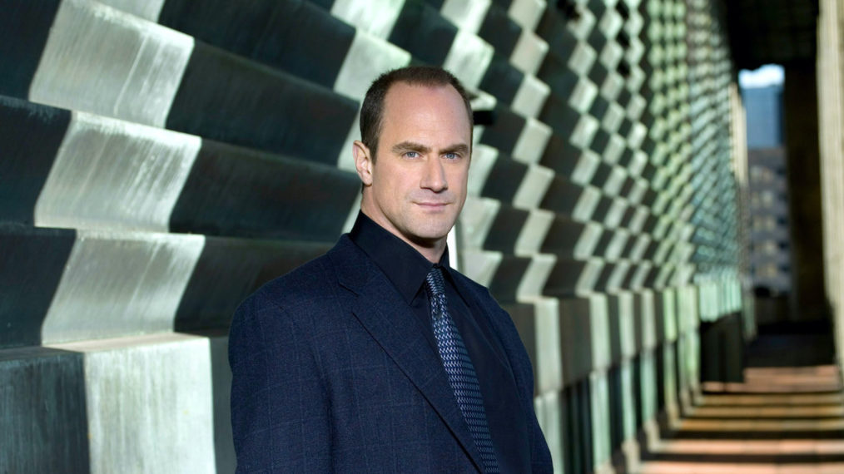

Virginia Sherwood © NBC / Courtesy Everett Collection

It remains unclear when we'll see [**Christopher Meloni**](http://tvinsider.com/people/christopher-meloni) stepping back into Elliot Stabler's shoes due to the latest news about the upcoming [***Law & Order: SVU***](https://www.tvinsider.com/show/law-order-svu/) spinoff, [***Organized Crime***](https://www.tvinsider.com/show/law-order-organized-crime/).

Matt Olmstead, who was supposed to serve as showrunner, has left the newest [**Dick Wolf**](http://tvinsider.com/people/dick-wolf) drama at NBC "amid challenges cracking the show's creative," according to [***The Hollywood Reporter***](https://www.hollywoodreporter.com/live-feed/chris-melonis-law-order-svu-spinoff-delayed-at-nbc-amid-showrunner-change-exclusive?utm_source=Sailthru&utm_medium=email&utm_campaign=THR%20Breaking%20News&utm_term=hollywoodreporter_breakingnews). A replacement has not yet been named, but this could delay when we finally see Stabler — and therefore his upcoming reunion with former partner (and now SVU captain) Olivia Benson ([**Mariska Hargitay**](http://tvinsider.com/people/mariska-hargitay)).

When NBC unveiled premiere dates for the "fall" part of its 2020-2021 season, *Law & Order: SVU*'s Season 22 premiere was set for Thursday, November 12, at 9/8c. *Organized Crime* is taking over the 10/9c time slot, though it is said to be launching in 2021. We'll have to wait and see just when it does debut.

Meloni was originally likely going to appear on *SVU* in the premiere to set up his upcoming spinoff, but the showrunner of the long-running drama, [**Warren Leight**](http://tvinsider.com/people/warren-leight), shared on Twitter on August 27 that [**plans had changed**](https://www.tvinsider.com/947522/law-order-svu-season-22-premiere-stabler-return-sir-toby/). "These days all plans are subject to change. And then they change again. And again. For now, we won't reintroduce Stabler until the night of his Organized Crime premiere," he wrote.

That means it'll be a while before fans see that reunion, which Meloni told [**TV Insider**](https://www.tvinsider.com/941933/law-order-svu-benson-stabler-reunion-christopher-meloni/) he expects that will "be heavily-laden with 10 years of stuff and a lot of emotion, not that it'll be an emotional scene."

[SEE ALSO](https://www.tvinsider.com/gallery/dream-tv-show-crossovers-ncis-law-order-svu-fbi/)

### [**7 Dream TV Show Crossovers We'd Love to See**](https://www.tvinsider.com/gallery/dream-tv-show-crossovers-ncis-law-order-svu-fbi/)

From the probable (with 'NCIS' series) to the least possible ('Prodigal Son' and 'Brooklyn Nine-Nine').

Instead of that return or picking up media mogul Sir Toby's (Ian McShane) trial, the "first few eps will see our squad grappling with many of the losses and changes and challenges we're all going through at this moment," he shared on September 1. That includes addressing George Floyd's death and the subsequent protests against police brutality and racism, and it's not the only police show that will be [**making changes as a result**](https://www.tvinsider.com/gallery/tv-shows-changes-2020-police-brutality-protests/).

*Organized Crime* is likely going to be affected as well. Meloni said in July that he expects his spinoff to address that the world has changed since we last saw Stabler (on *SVU* in the Season 12 finale). "We're really living in a very different world than we were 10 years ago," he noted. "It's just a new world that you find a character you knew from the olden days back in. You have to address that."

***Law & Order: Organized Crime*, Premiere, 2021, NBC**